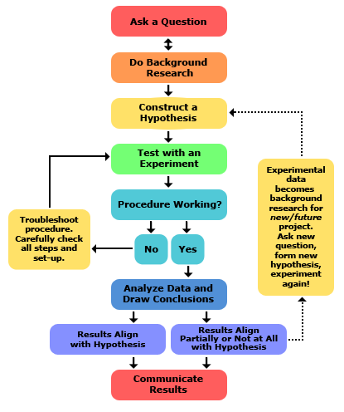

**DR. PAUL LICHTMAN**

**STARS SUMMER RESEARCH CAMP**

**COLD SPRING HARBOR KABRATORY**

**COLD SPRING HARBOR, NY**

**Scientific Method – Formulating Scientific Questions**

|  |
| --- |
| **Ask a Question:** The scientific method starts when you ask a question about something that you observe: How, What, When, Who, Which, Why, or Where?  For a science fair project some teachers require that the question be something you can measure, preferably with a number. |
| **Do Background Research:** Rather than starting from scratch in putting together a plan for answering your question, you want to be a savvy scientist using library and Internet research to help you find the best way to do things and insure that you don't repeat mistakes from the past. |
| **Construct a Hypothesis:** A hypothesis is an educated guess about how things work. It is an attempt to answer your question with an explanation that can be tested. A good hypothesis allows you to then make a prediction: "If _____*[I do this]* _____, then _____*[this]*_____ will happen."  State both your hypothesis and the resulting prediction you will be testing. Predictions must be easy to measure. |
| **Test Your Hypothesis by Doing an Experiment:** Your experiment tests whether your prediction is accurate and thus your hypothesis is supported or not. It is important for your experiment to be a fair test. You conduct a fair test by making sure that you change only one factor at a time while keeping all other conditions the same.  You should also repeat your experiments several times to make sure that the first results weren't just an accident. |
| **Analyze Your Data and Draw a Conclusion:** Once your experiment is complete, you collect your measurements and analyze them to see if they support your hypothesis or not.  Scientists often find that their predictions were not accurate and their hypothesis was not supported, and in such cases they will communicate the results of their experiment and then go back and construct a new hypothesis and prediction based on the information they learned during their experiment. This starts much of the process of the scientific method over again. Even if they find that their hypothesis was supported, they may want to test it again in a new way. |